**IS 375 C# - Intermediate**

**HOP01A –Visual Studio Code (VSCode)**

11/16/2019 Developed by Apiwat Chuaphan

Center for Information Assurance (CIAE) @City University of Seattle (CityU)



**Before You Start**

* If you already finished this module through other CityU School of Technology and Computing (STC) courses, feel free to skim this activity. But verify VSCode installation in your computer.
* Version numbers may not match with the most current version at the time of writing. If given the option to choose between stable release (long-term support) or most recent, please choose the stable release rather than beta-testing version.
* This tutorial targets Windows users and MacOS users.
* There might be subtle discrepancies along the steps. Please use your best judgement while going through this cookbook style tutorial to complete each step.
* For your working directory, use your course number. This tutorial may use a different course number as an example.

**Learning Outcomes**

* Installing VSCode
* Making your development directory

**Installing Visual Studio Code**

**Windows**

Installation

1. Visit <https://code.visualstudio.com/>

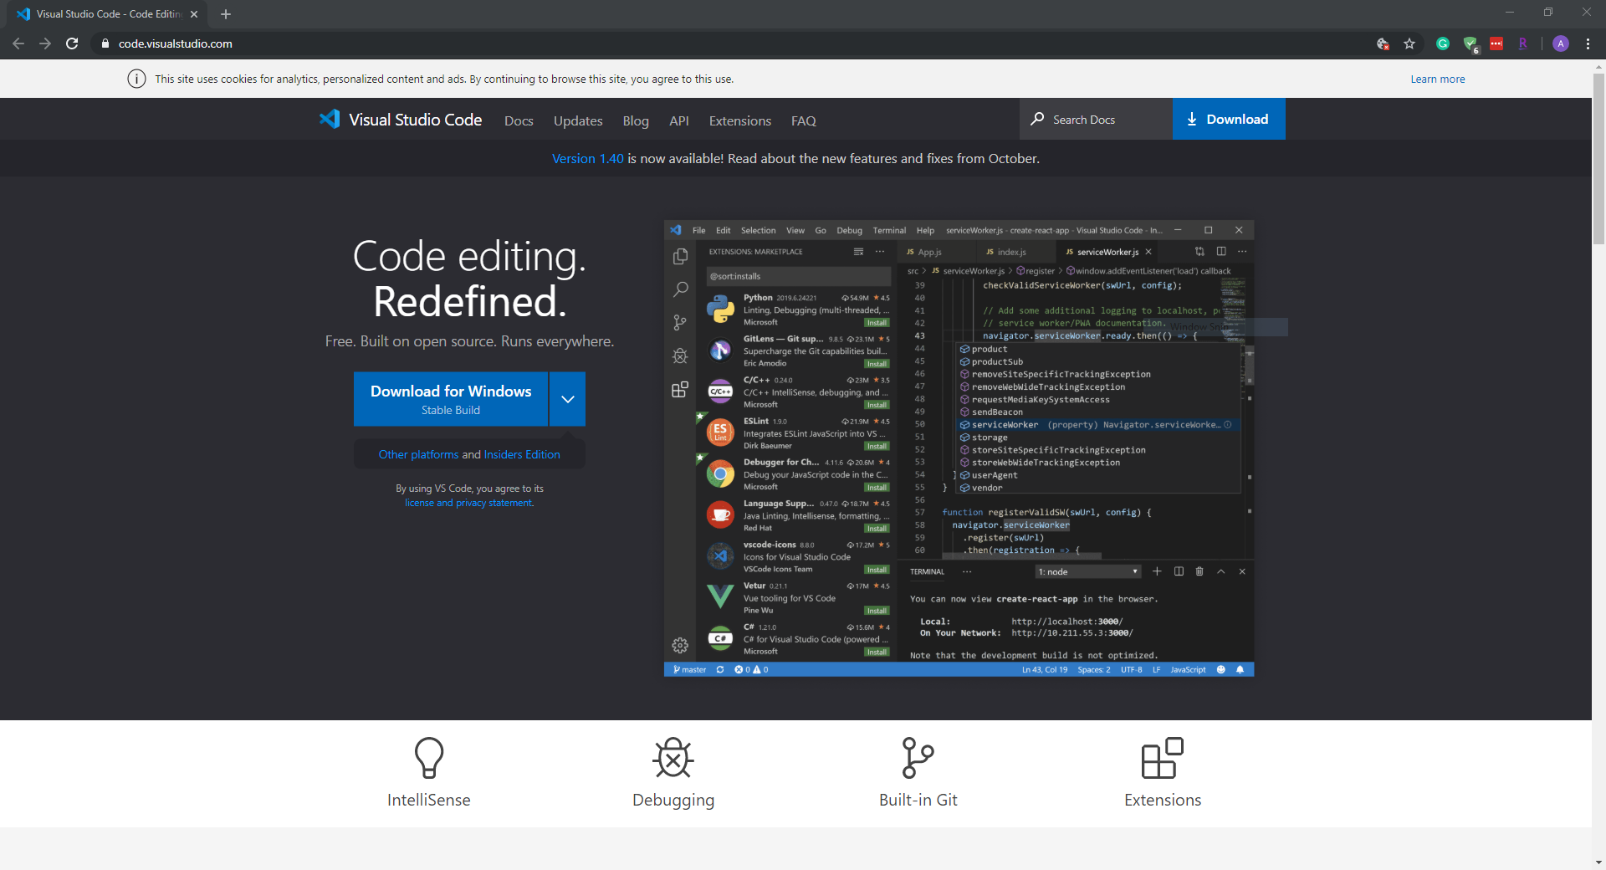

1. Select a correct version for your operating system and download it.  
   For example, you can download “VSCodeUserSetup-x64-1.40” for your Windows 10. (As of October 2019)

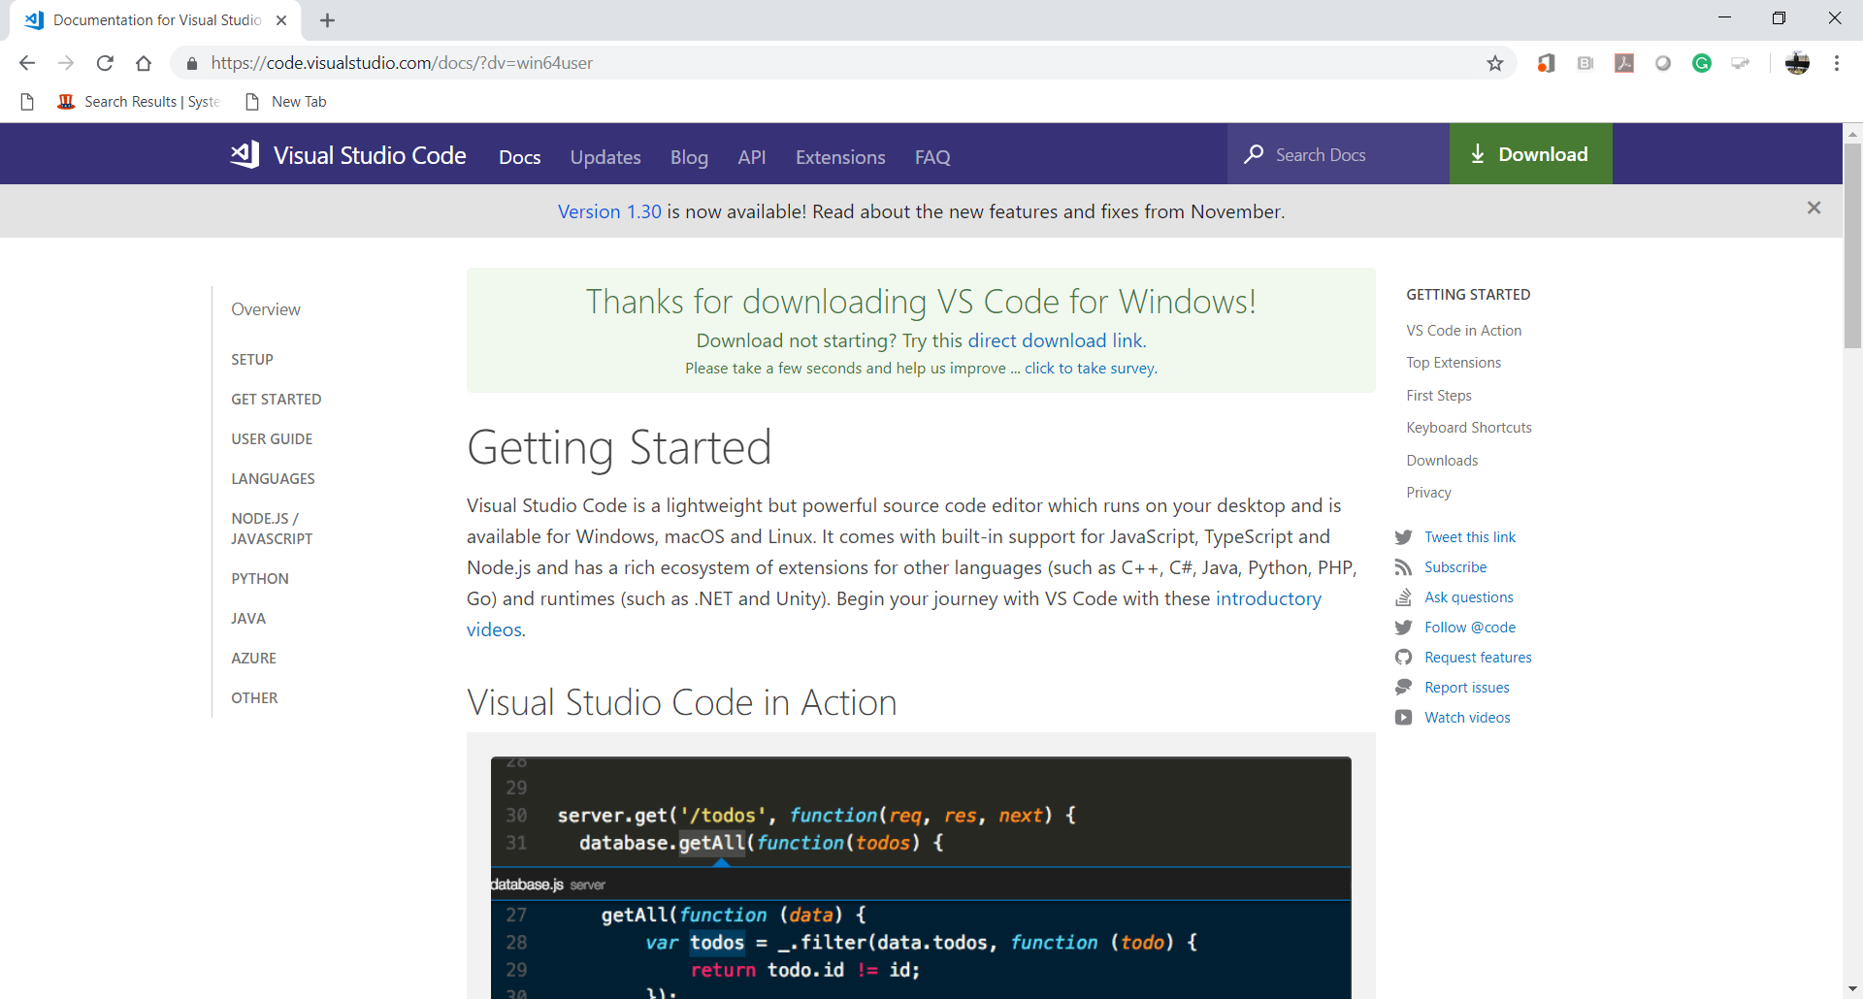

1. Install VSCode.

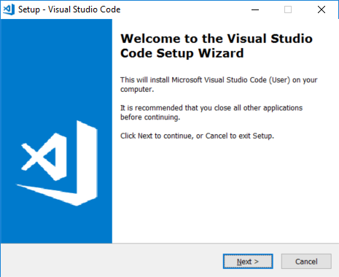

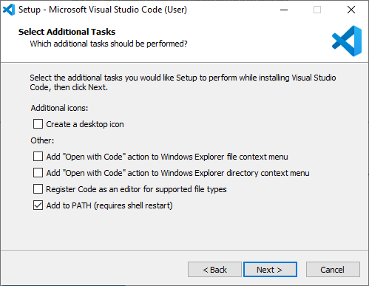

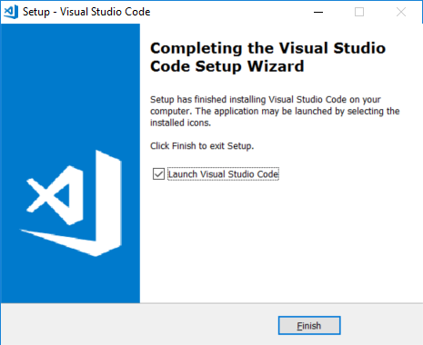  
  
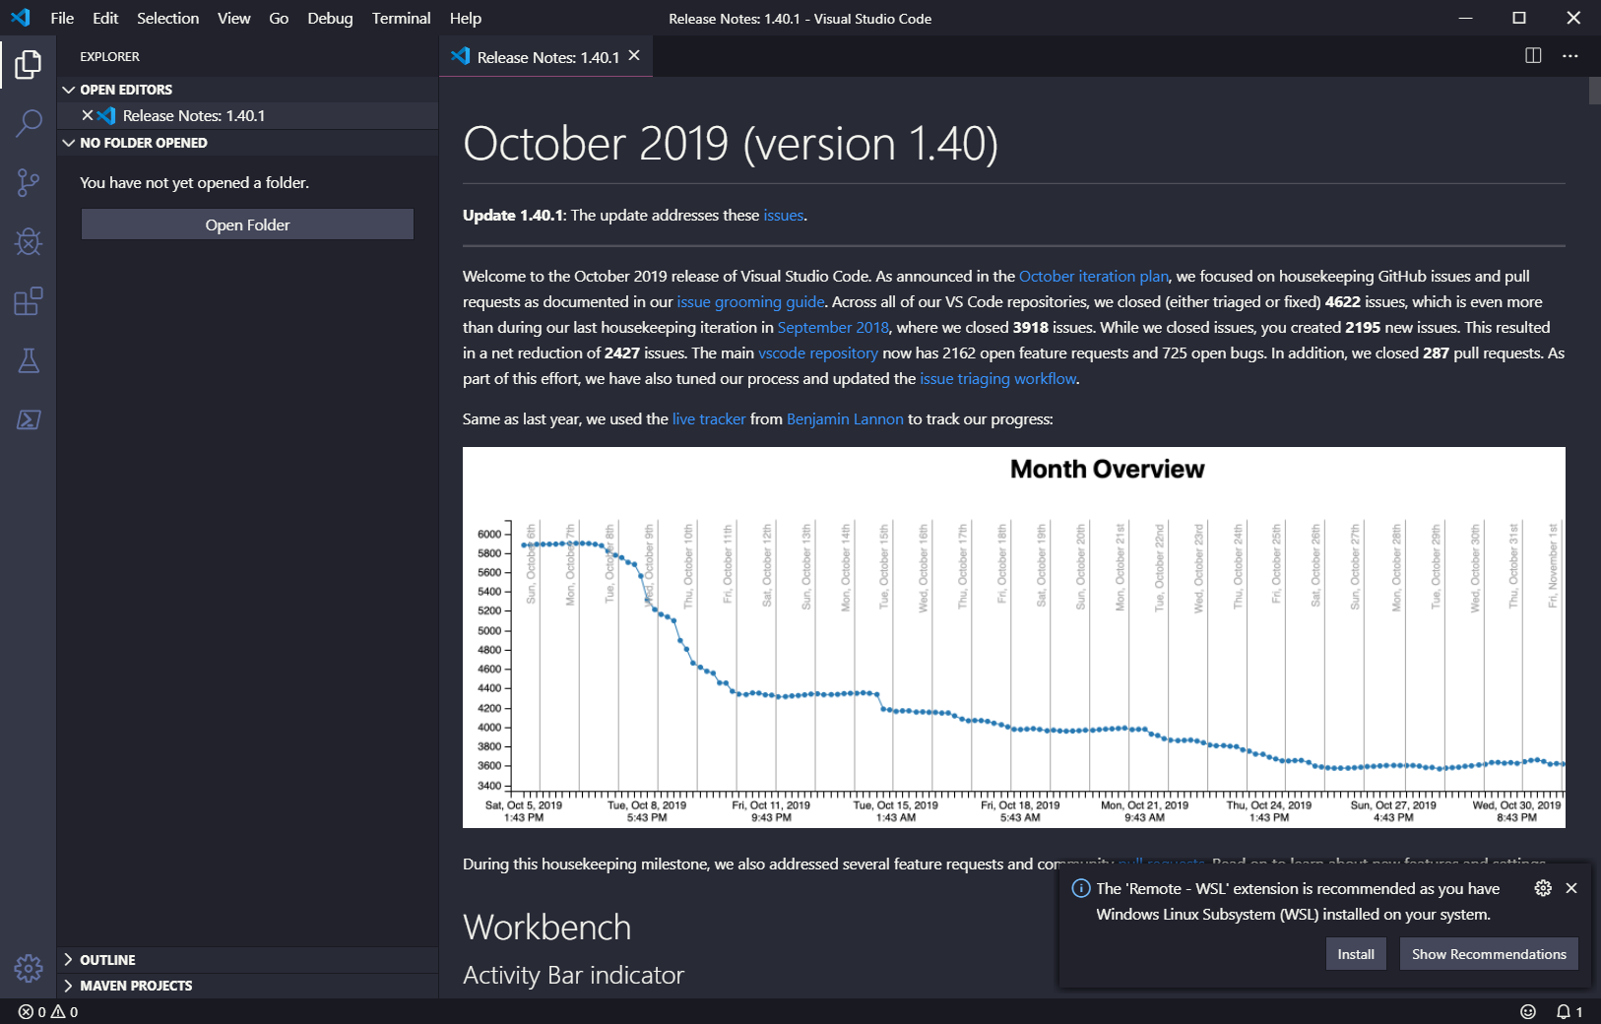

1. After installing the VSCode, close the opened VSCode.  
   Go to “File” menu end select ‘Exit” menu item.

**macOS**

Installation

1. Visit <https://code.visualstudio.com/>

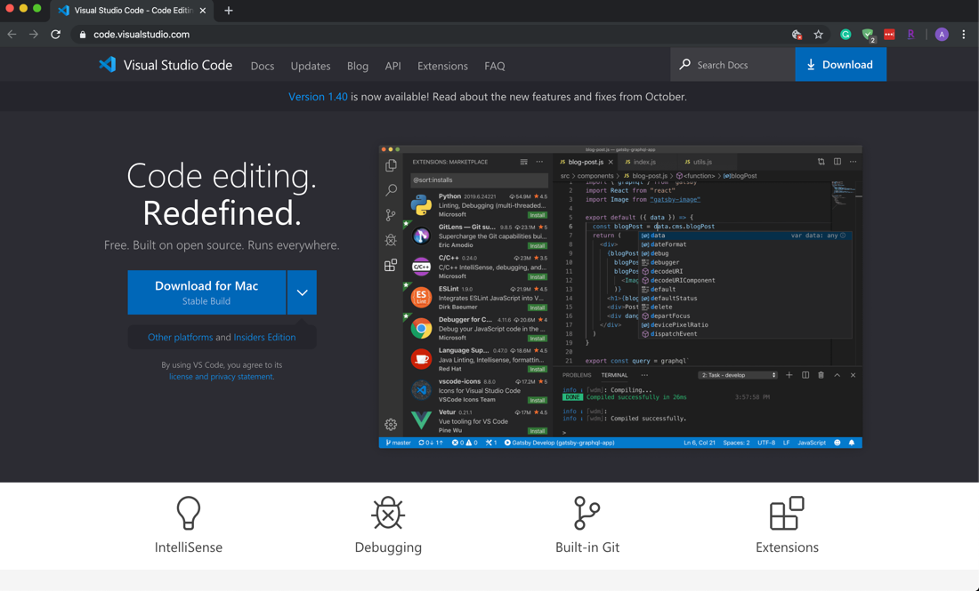

1. Click Download for macOS
2. Double-click on the downloaded archive to expand the contents.
3. Drag Visual Studio Code.app to the Applications folder, making it available in the Launchpad.
4. Add VS Code to your Dock by right-clicking on the icon to bring up the context menu and choosing Options, Keep in Dock.

Launching from the command line

(You can also run VS Code from the terminal by typing 'code' after adding it to the path)

* Launch VS Code.
* Open the Command Palette (F1) and type 'shell command' to find the Shell Command: Install 'code' command in PATH command.

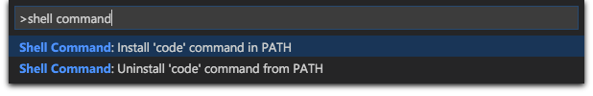

* Restart the terminal for the new $PATH value to take effect. You'll be able to type 'code .' in any folder to start editing files in that folder.

**Making your development directory**

1. Open the VSCode again.
2. Go to “View” menu and select “Terminal” menu item for your Command Line Interface (CLI).

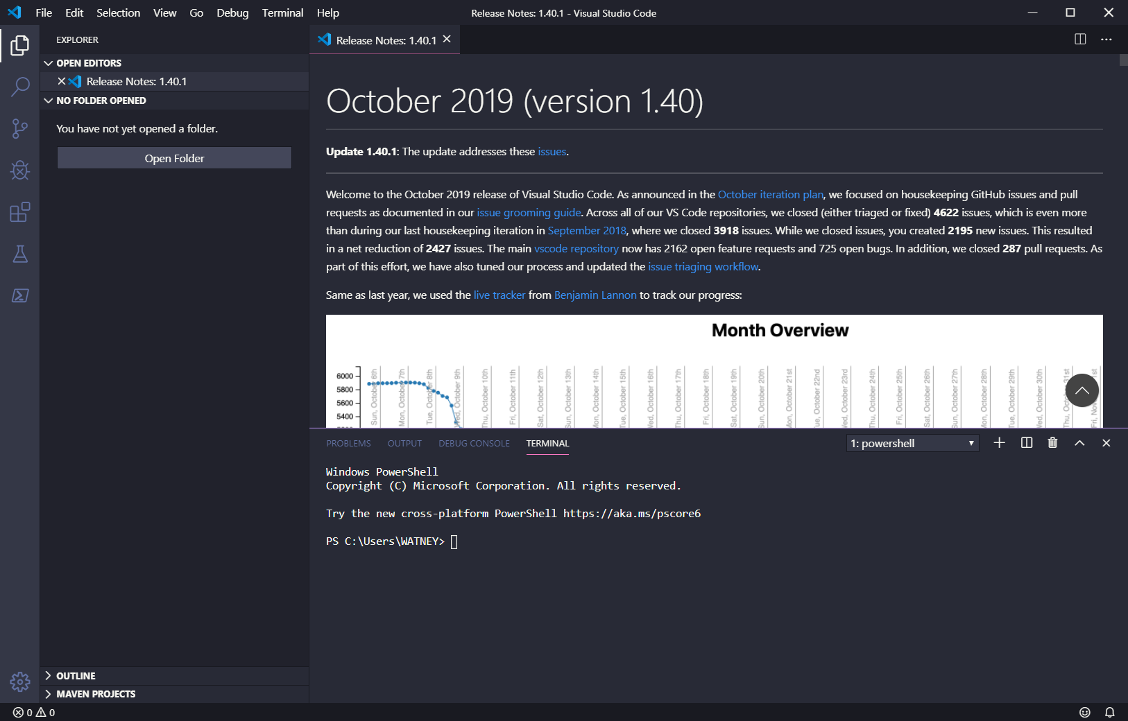

1. Go to the home directory of your disk drive.  
   Create a working directory called “**IS375**” for your course and move to the directory.  
   The following commands under Windows will be used.

Windows

* + cd ~
  + mkdir **CS547**
  + cd **CS547**
  + dir

MacOS

* cd ~
* mkdir **IS375**
* cd **IS375**
* ls

References to create a directory:

For Windows:   
<https://www.digitalcitizen.life/command-prompt-how-use-basic-commands>  
<https://www.thomas-krenn.com/en/wiki/Cmd_commands_under_Windows>

For Mac:

<https://www.cs.virginia.edu/diochnos/tips/terminal/basics.html>

**Caution**: the example below shows “**IS375**”. Use your course number.

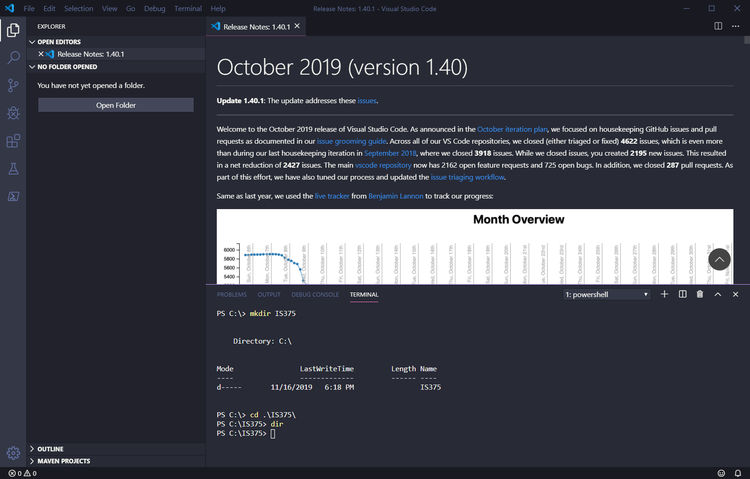

This example uses Windows commands, for macOS users, use commands mentioned above

1. Clear your CLI.  
   >>> cls (macOS, use clear)
2. Close the VSCode.

**Installing Node.js**

1. Visit <https://nodejs.org/en/>     
   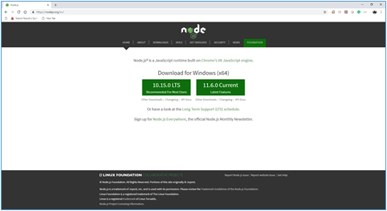

1. Download a file for your operating system.   
   For example, a Windows installer package called “node-v10.15.0-x64.msi” is downloaded.

1. Install the Node.js.   
      
   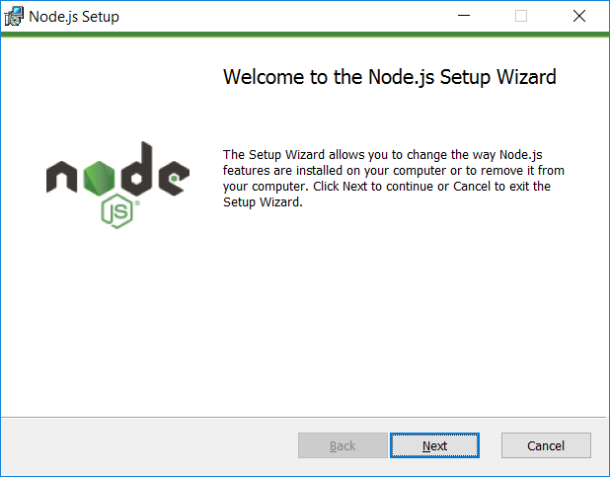

1. Open your VSCode and open the CLI.   
   Then, go to your ‘cs547’ directory and execute Node.js.   
   Then, show the Node.js is running.

C:\cs547>node   
>console.log('Node is up and running!');   
   
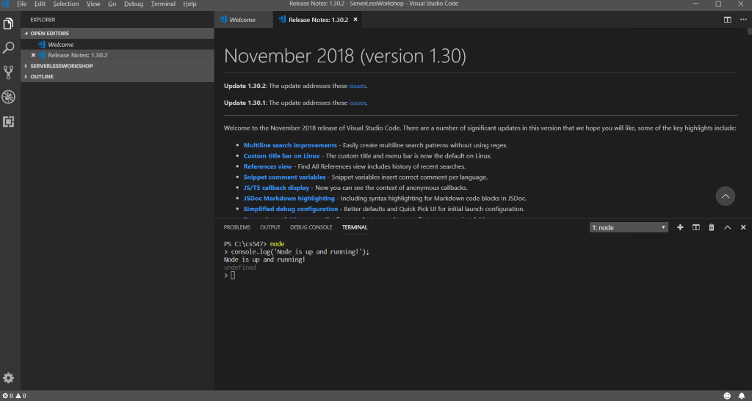

1. Go to “File” menu” and then select “Open Folder …”.   
   Then open “cs547”.   
      
   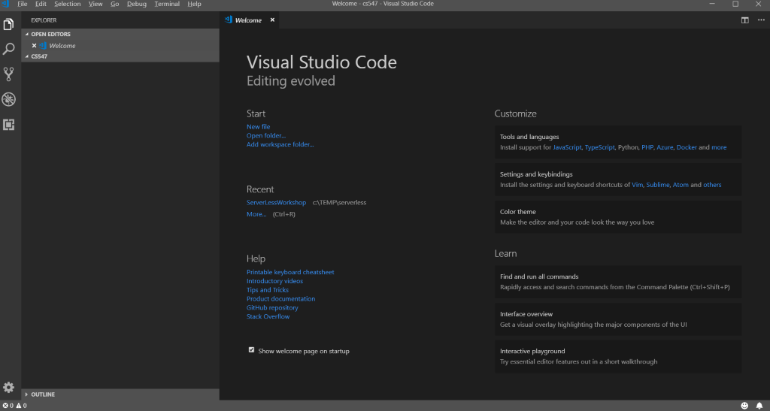
2. Create a file called ‘application.js’ under "cs547" and enter the console message into the JavaScript file. Save it and execute it.   
      
   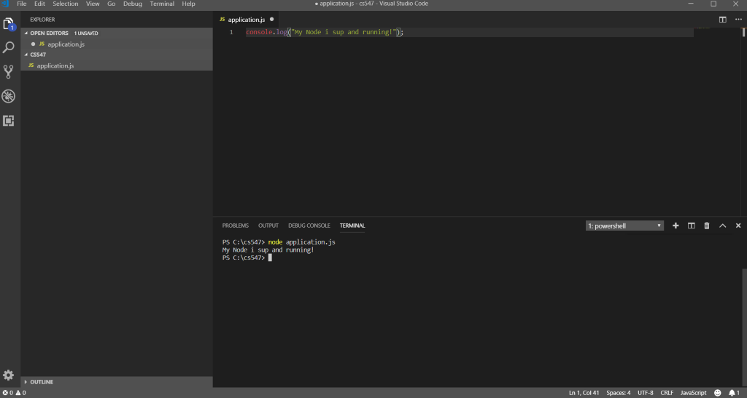
3. Close the VSCode.

### ENJOY CODING 😄 ###